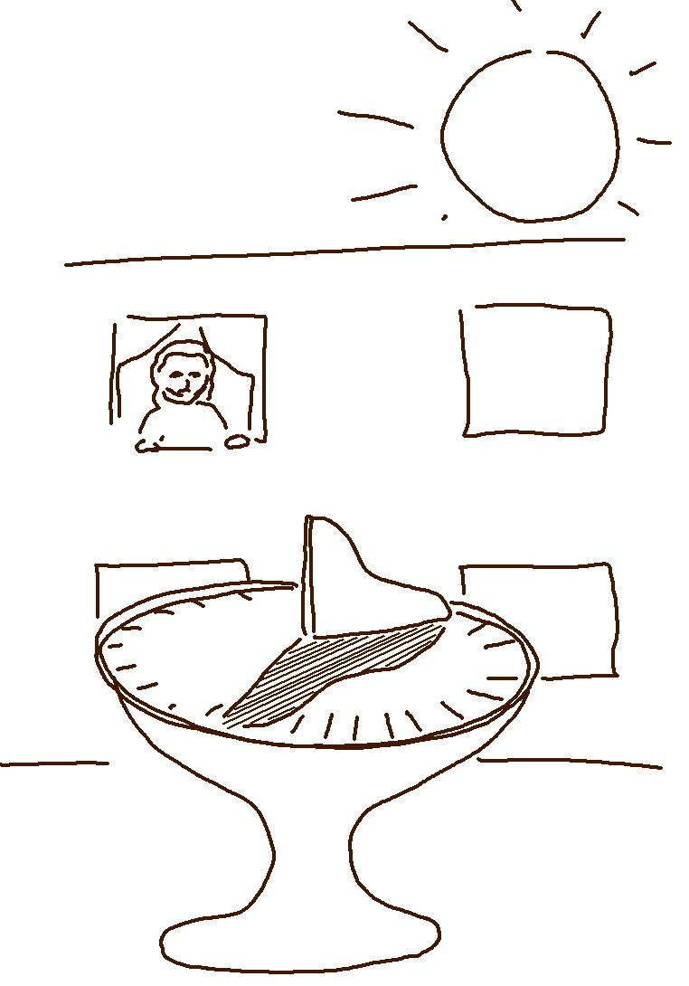
Don't fall into the trap of being a coward - trust the _ _ _ _, and you will be _ _ _ _.
Proverbs 29:25 _{NLT}

